**Instructions for Web Development**

1. Make notes

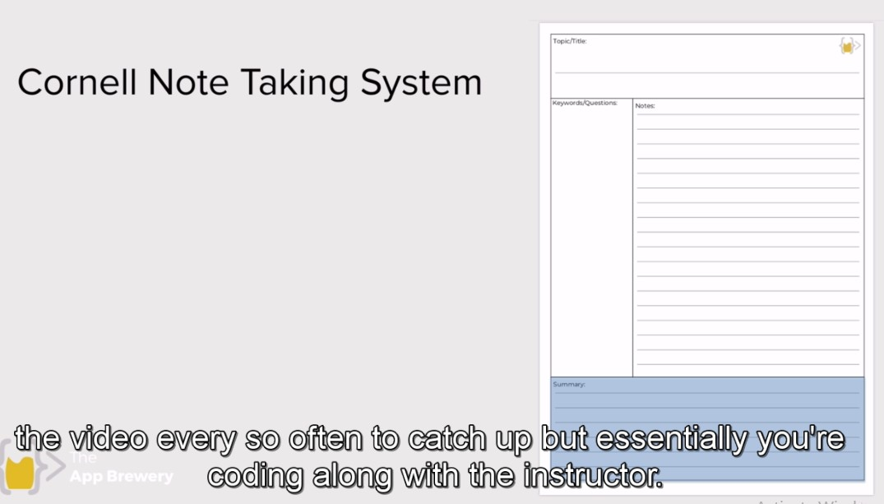

1. Bookmark difficult things
2. Practice difficult things as much as you can (Practice = Mystery)
3. Stuck? Watching movies, videos. Getting stuck is very much a universal part of programming something you have come to even learn and enjoy (It makes you professional programmer)
4. Finally, struggle is good

Google internet page ip address:

216.58.210.46

**Code Files**

1. **HTML:** HTML is the language for **describing the structure of Web pages**. HTML gives authors the means to: Publish online documents with headings, text, tables, lists, photos, etc. Retrieve online information via hypertext links, at the click of a button.Responsible for the structure of websites. It is used to add images, buttons,
2. **CSS:** CSS is the language for **describing the presentation of Web pages, including colors, layout, and fonts**. It allows one to adapt the presentation to different types of devices, such as large screens, small screens, or printers. CSS is independent of HTML and can be used with any XML-based markup language. It’s used for stilling our websites. Adding paintings, stylish boxes etc. To look websites as you want. Like button color, text editor color,
3. **JS (Java Script):** To add behavior like when you build your house you need electrician to connect wires. To add functionality. JavaScript is used by programmers across the world **to create dynamic and interactive web content like applications and browsers**. JavaScript is so popular that it's the most used programming language in the world, used as a client-side programming language by 97.0% of all websites.

**Ctrl+shift+C (Inspect Element):**

To know that the given website is made by using what elements.